# Media Analysis - Will ChatGPT and AI have an impact on Saudi workforce productivity

## Short Summary

The article examines the potential impact of ChatGPT on Saudi Arabia's workforce productivity, discussing both job displacement concerns due to automation and benefits such as increased efficiency by automating routine tasks, along with AI's role in enhancing skills development across various sectors.

## Summary

1. **Impact on Productivity**: ChatGPT and AI can boost productivity by automating mundane tasks, allowing employees to focus on strategic activities.   
2. **AI Culture**: Implementing AI technologies requires nurturing the right talent with a strong AI culture that promotes innovation, experimentation, learning, and collaboration.  
3. **Skills Development**: AI can positively impact recruitment, hiring, training, upskilling, reskilling, talent collaboration, and knowledge management through tailor-made programs and access to customized online courses.  
4. **Industry Transformation**: AI can transform sectors such as healthcare (personalized treatment), transportation (optimized routes), energy (oil exploration), finance (fraud detection), and retail (customer segmentation).  
5. **Job Replacement Concerns**: 48% of employees fear job loss to AI, but ChatGPT can replace workers in mundane, repetitive roles, potentially putting employee stability at risk.  
6. **Holistic Implementation Approach**: Embedding AI in Saudi companies' operations requires a strategic roadmap that defines objectives, advantages, and disadvantages, along with the selection of suitable AI tools for specific operational needs.  
7. **Leadership and Adaptability**: Successful AI integration necessitates strong leadership, a futuristic viewpoint, and adaptability to changes in both public and private sectors.

## Question 1:

How do the media (in our case = the sample we are analyzing) frame the public discussion about ChatGPT? Are there certain **metaphors** that keep cropping up?

The metaphors used in the article to frame the public discussion about ChatGPT include 'a useful tool', 'wave of change', 'boost productivity', 'emancipating it', 'tailored-made training programs', and 'optimistic environment for learning'. These metaphors emphasize the potential positive impacts of AI technologies on workforce development, efficiency, and strategic activities.

## Question 2:

Which role does the Arabic World play in the field of Artificial Intelligence in this article according to the author? Answer with 'Not mentioned' if not applicable.

Not mentioned

## Question 3:

How helpful is Artificial Intelligence for the Arabic world based on this article?

According to the article, Artificial Intelligence is potentially very helpful for the Arabic world, specifically Saudi Arabia's workforce and economy. It can increase productivity by automating repetitive tasks, freeing up time for strategic activities. AI also has the potential to enhance recruitment processes, training programs, and collaboration among employees.

## Question 4:

What is the final message of the article that the author wants to convey? Keep your answer short and precise!

The article conveys a balanced message about AI, acknowledging its potential benefits like increased productivity in various sectors while also addressing concerns of job displacement due to automation. It advocates for strategic planning, tailored AI tool selection, and cultivating an environment that supports adaptation to these changes.

## Sentiment

The sentiment is 4

## Entities

Khoury, Embedding AI, AI, Kaspersky, Raymond Khoury, Arab News, Arthur D. Little

## Topic Clusters

### Cluster: AI Impact on Society

Talent management, Employee adaptability

### Cluster: Knowledge and Optimization

Knowledge management, Transportation optimization

### Cluster: Problem Solving with AI

Bottlenecks resolution

## Word Clouds

### Wordcloud of content

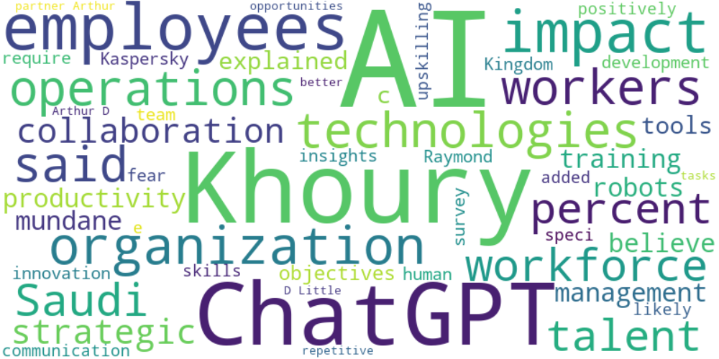

Top 10 words:

- AI: 34

- Khoury: 16

- ChatGPT: 12

- employees: 11

- impact: 9

- technologies: 6

- operations: 6

- said: 6

- workers: 6

- Saudi: 5

### Wordcloud of summary



Top 10 words:

- AI: 10